SW Menu
sw_contents.html — Software

NB You must take the PreQuiz to be able to access the modules!:
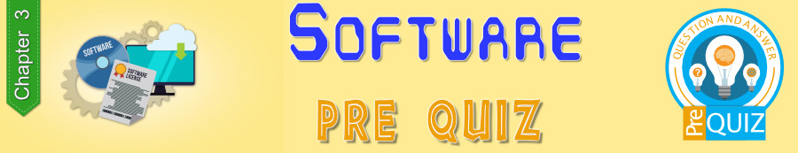

Modules for this Chapter:
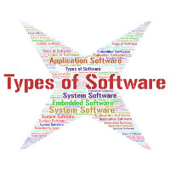
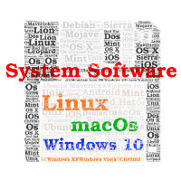
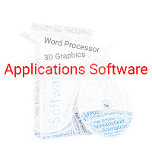
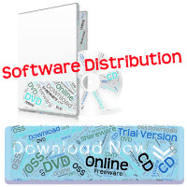

Take the Quizzes to help you learn!
